

In memory of

**Kathy Chester**

# This is the twenty-seventh annual seminar series sponsored through the Kathy Chester Memorial Endowment Fund. As a Riverside Speech Pathologist, Kathy was a strong advocate for continuing education and these seminars are a tribute to Kathy and her contribution to our field.

# The Twenty-Seventh Annual

Kathy Chester

# Memorial Seminar Series

***“Shakes and Breaks: An Update on Laryngeal Dystonia and Associated Neurological Voice Conditions”***

Karen Perta PhD, CCC-SLP Thursday, April 10, 2025

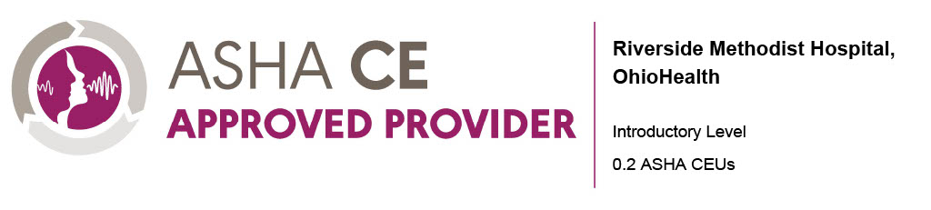

## Seminar Description

Voice disorders associated with neurological conditions, including laryngeal dystonia and tremor, present significant challenges for both patients and clinicians. These disorders often manifest as vocal breaks (laryngeal dystonia) and/or shakes (dystonic versus essential tremor), each with characteristics and comorbidities that can complicate accurate diagnosis. Recent functional imaging studies have deepened our understanding of the neurophysiology underlying laryngeal dystonia and tremor. This course provides an overview of the latest research and terminology updates related to these complex voice conditions, emphasizing clinical differentiation, assessment techniques, and evidence-based treatment approaches/referrals to better serve this challenging clinical population.

## Speaker

***Karen Perta, Ph.D., CCC-SLP*** is a voice-specialized medical speech-language pathologist, singing voice specialist, and researcher. She spent over 10 years in the Columbus area working in ENT and neurological acute care (Riverside Methodist Hospital) and completed her Ph.D. at the Ohio State University. She is former clinical faculty at Ohio University and is a current assistant professor in the Department of Communication Sciences and Disorders at Elmhurst University outside of Chicago.

**Financial Disclosures:**

* Receives a speaking fee from OhioHealth

**Non-Financial Disclosures**:

* Has no relevant non-financial relationships to report

## Learner Objectives

At the conclusion of the course, participants will be able to:

1. Describe the clinical characteristics that differentiate laryngeal dystonia, dystonic tremor, and essential tremor.
2. Identify assessment procedures for neurological voice disorders and potential functional voice co-morbidities.
3. Describe behavioral and medical treatment options for neurological voice disorders.

## Seminar Schedule

2:30-2:40 Neuroanatomy review and pathophysiology of neurological voice disorders

2:40-3:10 Overview of the clinical features of laryngeal dystonia (breaks) versus other related neurological voice conditions such as dystonic tremor, essential tremor (shakes)

3:10-3:25 Co-morbidities in neurological voice disorders, including functional voice disorders (e.g., muscle tension dysphonia)

3:25-3:50 Assessment tasks for neurological voice disorders and differential diagnosis

3:50-4:20 Behavioral and medical treatments for neurological voice disorders, including therapy options and appropriate referrals (laryngology and support group)

4:20-4:30 Q & A

**Location**

Virtual or In-Person

OhioHealth Riverside Methodist Hospital

3535 Olentangy River Road

Susan H. Edwards Auditorium

Columbus, OH 43214

**For more information or questions, contact:**

Rehab Education

Email: [RehabEducation@ohiohealth.com](mailto:RehabEducation@ohiohealth.com)

## Registration

Register online at:

<https://ohiohealth.cloud-cme.com/KC-Shakes-and-Breaks>

**$50.00**